RED BARN WELLNESS FARM
YOGA TEACHER TRAINING APPLICATION

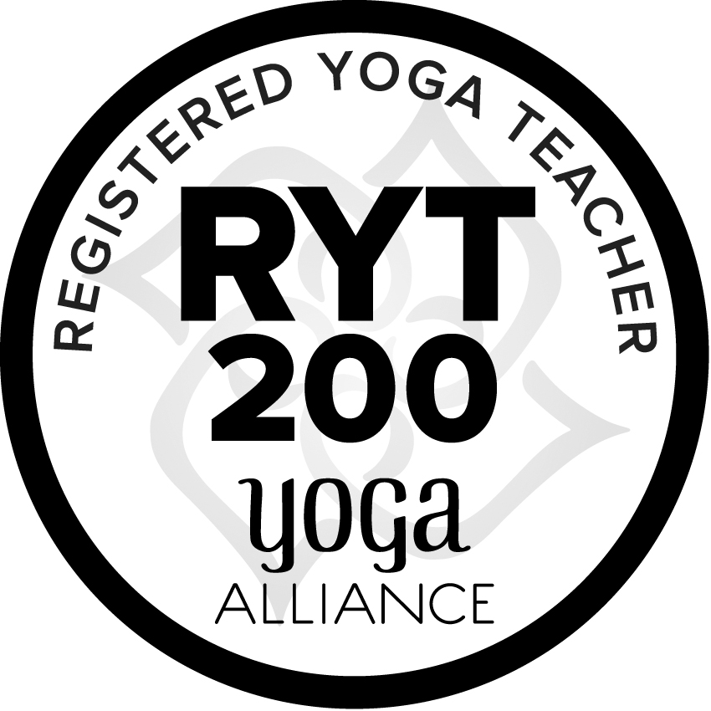

Full Name:

Mailing Address:

Telephone:

Email:

Date of Birth:

Please describe your previous yoga/meditation experience:

Please briefly tell us about your professional work history and training programs:

Please share why you are applying to become a Certified Yoga Teacher:

Are you interested in taking this program as part of the Learning Path to becoming a Horse Wisdom Yoga® Certified Teacher? Y / N (please circle one)

Do you have any health/medical concerns that may impact your ability to learn Yoga Asana (postures) and engage in spiritual practice (sadhana)? Please also inform of any allergies (food, environmental and otherwise).

Signed: _______________________________ Date: _________________

*I hereby acknowledge that this program may be subject to changes without notice

