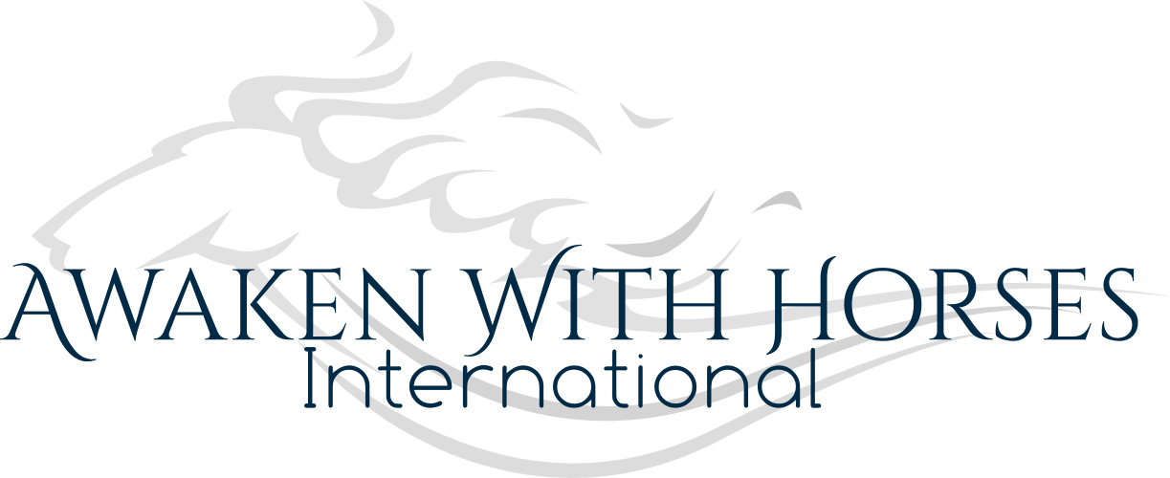
THE SACRED HORSE STEWARDSHIP PROGRAM
January 29 – March 25, 2024 Mondays from 6-8pm EST
LIVE via Zoom
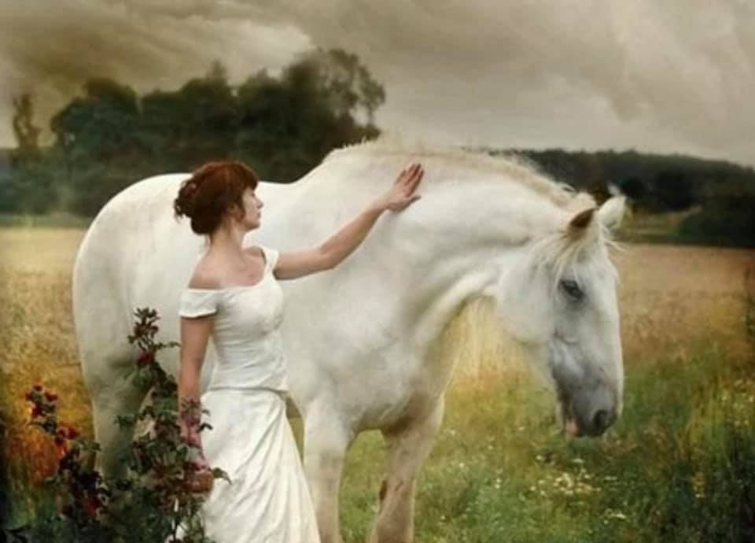
With the Horse as their teacher, these experts will be guiding your higher learning experience:
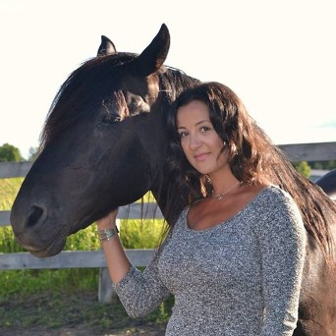

FOTINI CHANDRIKA, AWAKEN WITH HORSES INTERNATIONAL

Fotini Chandrika has been connected with Horse from as early as she can remember. Having been born and raised in the big City, this connection was spiritual in nature until about two decades ago when she began exploring the world of Horses in a more physical form. She has spent the past twelve years as devoted Steward and Listener to four Horses, Spirit, Malachi, Penny and Isa, with whom she partners in their Equine Guided Wellness practice at Red Barn Wellness Farm in Ontario, Canada. She is a born empath and has lived in the wonder of sacred communion with the Animal Kingdom and at home in the Natural world since her earliest memories of childhood.
Fotini is the full time Steward of four Horses; Spirit, Malachi, Penny and Isa, who form a bonafide mixed herd, living together for over a decade. She has cared for Spirit since he was a foal and is also experienced with senior Horses, with the Eldest of the Herd, Malachi, being 35 years wise!
Fotini is the founder of Awaken with Horses International and the ‘unLearning Path’, where she and the Horses offer a unique co-creation in Equine Guided Wellness called ‘Horse Wisdom Yoga®’. Horse Wisdom Yoga® offers an opportunity for individuals, partners and small groups to engage in connection, creativity and compassion through equine guided experiences. This model brings together the philosophies of the ancient practice together with the wisdom of Horse for an experience of self-discovery in an environment conducive to higher learning and healing.
Fotini has spent the past two decades in deep study and practice of a wide variety of holistic modalities that have played an important role in the wellness and healing of herself and the Horses she cares for. She carries mulit-certifications in the study of Yoga, Meditation, Ayurveda and is a certified Aromatherapist. She is also a certified Equine Aromatherapist and has studied Herbalism, Energy Healing, Bodywork techniques and so much more. She works with the vibrational frequencies of essential oils, crystals, smoke medicine, sound bowls and oracle cards within her Stewardship practice.
Most of all, Fotini has learned to become a quiet listener of the Horses, which has taught her more about Horses and herself, than any other area of study. She considers the Stewardship role to be a sacred, devotional practice and is humbled to share her life with the wisdom and majesty of Horses.
Through The Sacred Horse Stewardship Program, Fotini shares her knowledge with Stewards from around the world, while helping Horse Stewards deeply connect with the wisdom and intuition that is innate to them. In doing so, Stewards are empowered within their relationship with Horses.
For more information about Fotini, her areas of study, personal experiences and professional practice, please visit www.awakenwithhorses.com/about
For highlights and stories, please follow @awakenwithhorses on Instagram
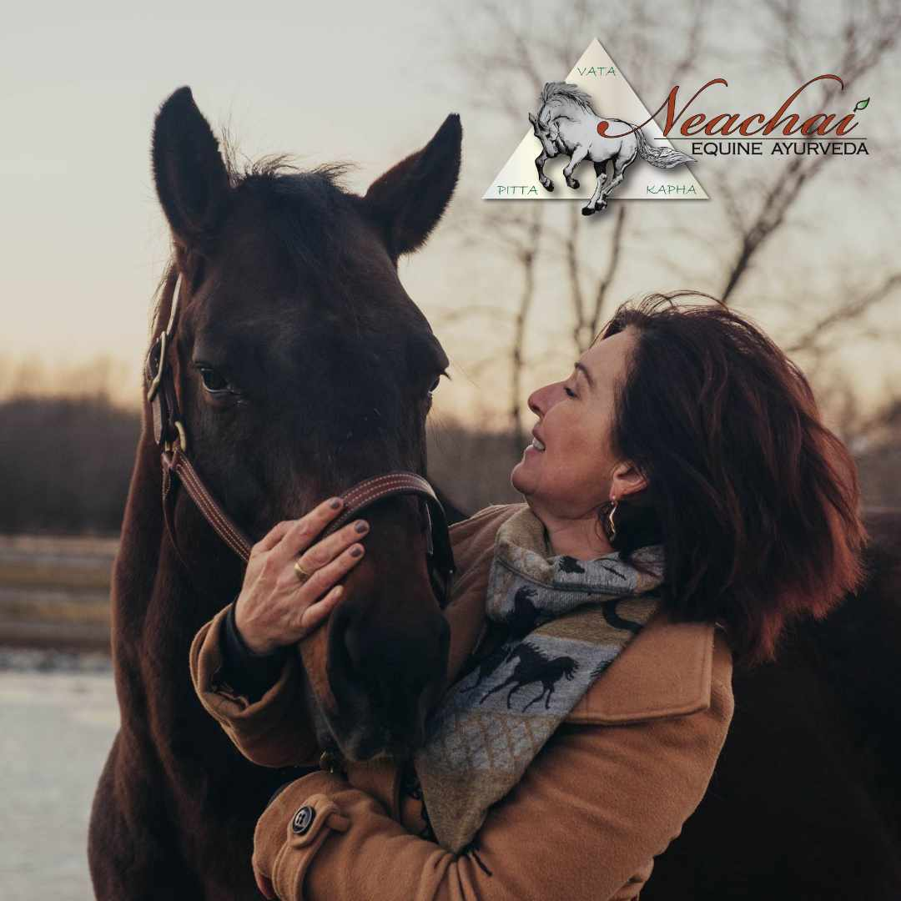

THERESA GILLIGAN, NEACHAI EQUINE AYURVEDA

With over 30 years working with horses, Theresa combines her education with animal science and biomechanics with the lifestyle science of Ayurvedic medicine. The marriage of these two sciences provides the foundation of root cause medicine. After almost losing her own horse to a severe respiratory disease at the age of 11, she sought out to find an answer outside of the conventional medicine model. The concepts of bio-individual treatment in Ayurveda created the intrigue that began the educational journey and the creation of Neachai Equine Ayurveda.
Her passion for equine health and wellness, and a deep-rooted love for Ayurvedic medicine, Theresa is committed to changing the face of animal healthcare by employing disease prevention strategies.
Pioneering the field of Ayurvedic Veterinary science in North America ,Theresa is in the process of developing a groundbreaking course on Veterinary Ayurveda, the original veterinary health science dating back 5000 years. This initiative promises to reshape the way veterinary medicine is approached, introducing practitioners to the holistic and individualized healthcare practices that have been a cornerstone of Ayurveda for centuries.
Theresa’s commitment to horse health and wellness is rooted in advocating and educating prevention using nutrition , bodywork and plant based medicine. She works with owners and their horses from every corner of the world on how to recognize the signs of dysfunction before they become dis-ease.
Through curated nutrition programs and traditional formulations, based on the bio-individuality of each horses unique constitution, she can alter the disease path and heal the gut, the root cause of all disease, from commercially processed foods.
Theresa’s ongoing work can be found through the Neachai Equine Ayurveda site and social media pages where online courses will soon be available.

JESSE MCCOWAN, BIRCH ANIMAL WELLNESS

As a highly intuitive and empathic child, Jesse struggled to understand why the world felt so disconnected. Luckily, she had exposure to holistic healing from a very young age and soon realized she wanted to expand the therapies she was learning about to her animal friends.

Jesse McCowan is a Holistic Wellness Practitioner for Equines, Canines, and Felines. She received her Honours Bachelor of Science with a Specialization in Animal Behaviour in 2015. Jesse is now certified in Animal Iridology, Animal Acupressure, Flower Essences, Cold Laser, Animal Reiki, and Animal Communication with additional training in Nutrition and Homeopathy.

Lately, her work has been pushing her more into the realm of healing using a combination of energy work and animal psychology. She is currently pursuing her Masters in Counselling Psychology to specialize in Animal Assisted Therapy. Her soul work is showing people the healing power of animals to heal their inner wounds.
On a personal level, Jesse thrives in nature and has been vegan for 5 years. Her love for the planet and its inhabitants permeates all aspects of her life. She identifies as a minimalist and has a teacher in her 8 year old Australian Shepherd who she explores nature with. Someday she will have a tiny house in the woods and run Animal Therapy and Holistic Wellness workshops.

Website: www.birchanimalwellness.com
Instagram: @birchanimalwellness

AND OUR SPECIAL GUEST…
world renowned clinician, speaker, animal communicator…
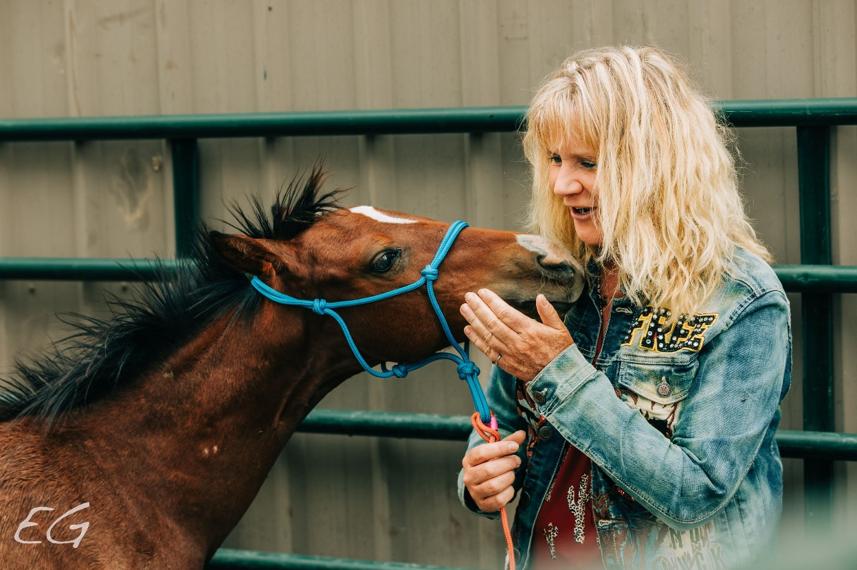

ANNA TWINNEY, REACH OUT TO HORSES

Anna is an International Equine Behaviorist, Clinician, Speaker, Author, Animal Communicator, Holy Fire®Karuna Reiki Master, life coach and the founder of Reach Out to Horses®. She is recognized by the United States Government as one of the top professionals in her field, through her unique and effective, collaborative and communication training methodologies. For almost 3 decades she has brought her highly successful, gentle approach to over ten thousand individuals and horses worldwide, from all walks of life and equine disciplines. She has conducted over one thousand clinics and classes across the globe and was the first female clinician to take natural horsemanship to China and Mongolia.

For over 30 years Anna has been involved in horse rescue and rehabilitation and specifically the protection of the American Wild Horse. Her assistance has been sought by numerous organizations including some of the largest rescues in the USA. She has raised hundreds of thousands of dollars for the horses in need and over one hundred organizations that share her passion for our majestic planetary companions. Anna hasgentled and trained over 1.5 thousand wild horses including those in the Premarin (PMU) industry, nurse mares and foals, feral and wild mustangs, feedlot foals, and tribal horses, exposing these often hidden industries. Some of the most well-known mustangs have come under Anna’s tutelage including the famous trio; Monty Robert’s Shy Boy, Spirit (the Mustang from the Cimmaron) and Excalibur, her own Spanish Mustang heart horse whose influence brought telepathy to the forefront for future generations.

Her work has been featured around the globe in magazines, newspapers, radio shows, internet programs, podcasts, summits and television, including F.E.I., a segment on China State TV, Martha Stewart’s “Living”, the BBC fly on the wall documentary “Living in the Sun”, and the French travel show, “Echappées Belles”. Reach Out to Horses® has appeared on the NickerNetwork.com, the Dutch Equine Network, Horse Lifestyle, and the CanDo Network of programming and most recently on Equus TV with her fly-on-the-wall "Successful foals in training" and "wild horse whispers" trainings. Following the call of the horses, Anna is also the editor and author of “Escaping Tradition” and two further books “Beyond the Barn I and II” featuring two decades of her life’s work.
Reach Out to Horses®
www.reachouttohorses.com
Equine Specialist, Animal Communicator, Energy Healer, Author & Speaker
Office: (888) 282-0656
Join me on Facebook: www.facebook.com/AnnaTwinneyHolisticHorsemanship
https://www.facebook.com/ACwAnnaTwinney/

